Memo

To: Professors Pisano, Osama, Hirsch, and Lagoy

From: Linden Adamson, Jason Calalang, Tara Gill, Zhilang Gui, Cole Resurreccion, Raina Yin

Team: Team 7 - Bike for Blind

Date: 4/10/2025

Subject: Final Project Testing

**Boston University**

**Electrical & Computer Engineering**

**EC464 Senior Design Project**

**Final Testing Report**

**Blind Bike**

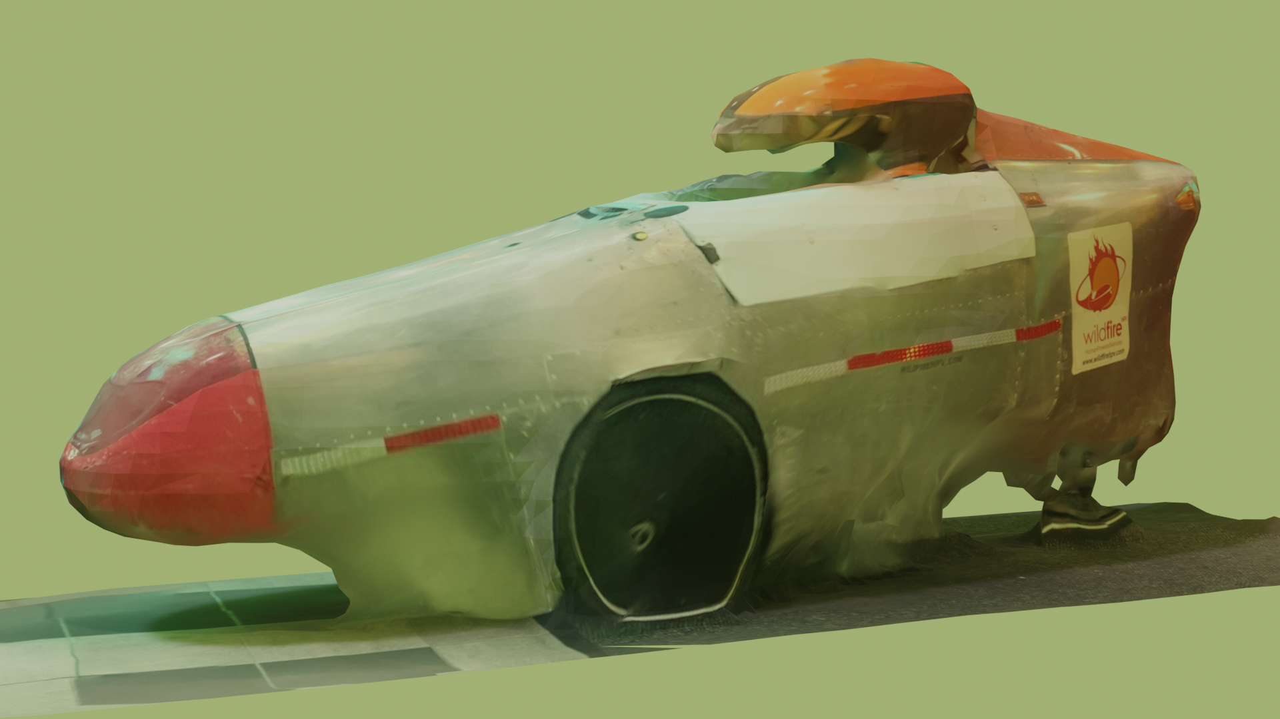

**By**

**Team 7**

**Bike for Blind**

**Team Members**

**Linden Adamson** [lindena@bu.edu](mailto:lindena@bu.edu)

**Jason Calalang** [jasonc16@bu.edu](mailto:jasonc16@bu.edu)

**Tara Gill** [taragill@bu.edu](mailto:taragill@bu.edu)

**Zhilang Gui** [zgui@bu.edu](mailto:zgui@bu.edu)

**Cole Resurreccion** [coler@bu.edu](mailto:coler@bu.edu)

**Raina Yin** [ryin2@bu.edu](mailto:ryin2@bu.edu)

**Required Materials/Equipment**

Hardware:

* Jetson Orin Nano Super Developer Kit
* OAK-D RGBD Camera
* 2x 12V Trucklite 15200Y (steering and braking lights)
* 2x DS5160 60 kg*cm Servo Motor
* PCA9685 Motor Driver
* NFP-36GP-555-EN 24V Geared Motor
* DC Motor Driver L298 Dual H Bridge Motor
* 19V 4.2A Barrel Jack Power Supply
* 2x Arduino Uno R3
* Arduino Uno R2
* Hilitand 4-Channel MOSFET PWM
* 433MHz RF transmitting button
* RXB6 433MHz Superheterodyne Wireless Receiver Module
* 90dB Piezo Buzzer
* 3x 3.3V ERM coin motors (haptics)
* 5x DC-DC Step-Down Converter 5A maximum
* 2x Weize 12V 12Ah SLA batteries connected in series

Software:

* Arduino Code
  + Brake and Steering script - flashed to Arduino Uno R3
  + Key Fob script- flashed to Arduino Uno R2
* Collision Avoidance
* Manual Stop Button
* Orin Nano ROS2 Nodes
  + Keyboard Operation (for control)
  + Braking Command
  + Steering Command
  + OAK-D ROS2 Nodes
  + Vectornav

**Set-Up**

First, every component must be wired according to the diagram below.

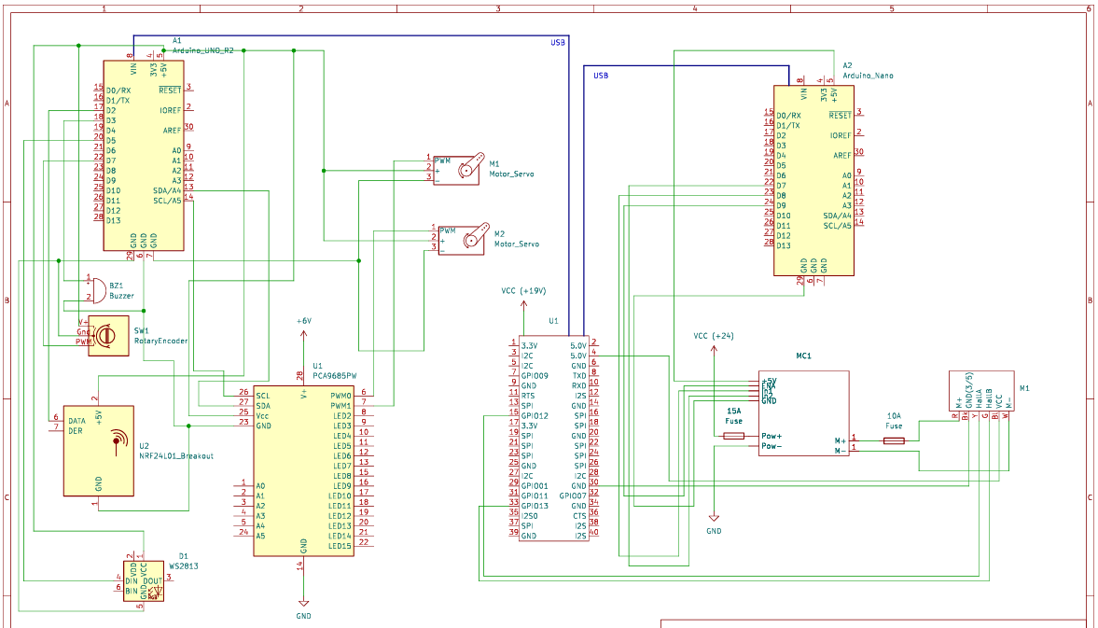

Figure 1: Circuit Schematic of Prototype System

Once all the components are appropriately connected, ensure no exposed wires contact the aluminum frame to cause a short. After confirming connections, turn on the battery switch to supply power to the necessary components.

* Arduino Nano and Uno should get power from the USBs provided by Orin.
* Connect the 6V buck converter output from the battery to the PCA9685 servo driver.
* Connect the 24V buck converter output from the battery to the motor controller and set the output to 24V.
* Power the Orin with the 19V barrel jack plug which is connected to the battery via buck converter.
* The braking and steering lights should be powered from the battery via a 12V buck converter.
* The OAK-D should be powered from an Orin USB port.
* The Vectornav should be powered from an Orin USB port.

For proper braking tests, both of the DS5160 servo motors should be mounted and attached to the trike.

For the braking system test, the Arduino Uno will be connected to the Jetson Orin. The brake light and PCA9685 motor driver will be connected to the Arduino Uno. The DS5160 servo motors will both be connected to the PCA9685 motor driver, with each servo motor mounted onto the trike’s front two brake pads.

For the key fob, a 433MHz RF receiver and a 90dB Piezo buzzer will be connected to the Arduino Uno R2.

For the steering system, the NFP is directly connected to the center axle of the trike controlling the steering. The NFP should be plugged into the controller and the encoder output should be attached to the Arduino.

For object detection, an OAK-D camera will be mounted onto the trike and connected to the Orin.

**Pre-testing Setup Procedure:**

On Orin Nano:

1. Plug in the Orin Nano. The correct commands should automatically run. SSH to the Orin via *10.239.146.85* and run the command *ros2 run tester key_op*

Power System

1. Connect the 2 12V batteries in series and press the on switch.

**Testing Course Setup:**

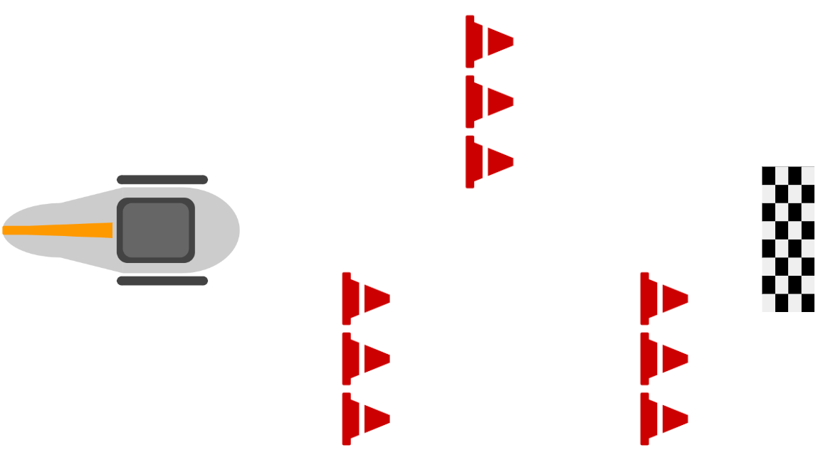

*Visual representation of the obstacle course to simulate a straight line with adaptive turning by weaving–distance between objects and sizes are not to scale. Driving distance between each cone segment should be at least 1.5m.*

**Testing Procedure:**

The user can access the trike with a key fob and begin pedaling when ready to go.

**Accessibility Feature: Key Fob**

1. Stand 10m away from the trike (powered off) and use the keyfob by pressing the RF button transmitter and hearing the sound from the buzzer to find the trike.

**Manual Control**

1. On the keyboard operation terminal:
   1. Type the character *s*. The brakes should engage and the LED brake lights should turn on.
   2. Type the character *w*. The brakes should disengage and the LED brake lights should turn off.
   3. Type the character *j*. The steering motor should turn left.
   4. Type the character *k*. The steering motor should stop.
   5. Type the character *l*. The steering motor should turn right.
2. Manual brake
   1. Engage the handlebar brake on the inside of the vehicle. The brakes should engage.
3. Remote steering and braking with obstacle
   1. Arrange an obstacle course using cones placed in a predetermined pattern along the test route.
   2. The user sits on the bike, ready to pedal, and prepared to control the steering and braking through the keyboard.
   3. Using the keyboard, the user maneuvers the bike carefully through the course, demonstrating precise manual steering.

**Collision Avoidance**

1. Activate emergency braking software
   1. Clear OAK-D camera’s sightline of any object 3m or closer. The brakes should not be engaged.
   2. Walk to within 3m of the OAK-D camera (2m from the nose of the trike). The brakes should engage. Haptic feedback on the seat must activate to signal to the user that braking is occurring.
   3. Leave 3m sightline of OAK-D camera. The brakes should disengage. The haptic feedback should return to idle, signaling to the user that the brake is no longer active.

**Navigation**

1. The bike should autonomously make a take a left turn on the preplanned path
   1. Set up the bike on Cummington Mall.
   2. User sits on the bike and starts pedaling, preparing to take a left turn from Cummington Mall away from the Photonics building
   3. As the turn is initiated, the trike’s steering system should engage automatically and maintain a smooth and precise transition through the turn.
   4. The IMU continuously records data and adjusts the trajectory as needed to ensure optimal path planning throughout the maneuver.
   5. During the turn maneuver, the corresponding turn signal lights should automatically illuminate to indicate the intended direction.
2. Repeat each of the above testing procedures 5 times to prove consistent accuracy of our system.

**Measurable Criteria**

1. Key fob will activate the buzzer at least 10 meters away from the trike with 80% accuracy.
2. Brake lights and brakes engage within 0.1s of receiving brake command from the Orin Nano with 100% accuracy.
3. Brakes will engage when an object is within 3m of OAK-D camera sightline (2m from the nose of the trike), and disengage when there is no object within 3m of OAK-D camera sightline with 90% accuracy.
4. Manual handlebar brake will engage the brakes with 100% accuracy. The system should confirm full brake engagement within 0.2 second. It should also override the braking command from the emergency brake.
5. Brake servo motors rotate enough to engage the brake pad with 100% accuracy. The response time for this and the haptic feedback should not exceed from command issuance to brake engagement must not exceed 0.2 second.
6. The steering motor will rotate in response to the motor command, and the rotation angle must match the command input within the tolerance of 2 degrees to ensure accurate steering.
7. The steering motor restricts itself from over-rotating/stalling.
8. During the obstacle course evaluation, the bike must not collide with the cones throughout the maneuver. In repeated tests, the bike should navigate the course without any impact on the cones in at least 95% of the trials.
9. Upon receiving the command, the steering motor should rotate the front 2 wheels to achieve a minimum turning angle of 20 degrees within 0.5 seconds and with 90 percent accuracy.
10. The trike must follow the planned route closely, deviating no more than 30 centimeters from the intended path. This performance should be observed in at least 90 percent of tests.